Answers | Coding Efficiency | Viva | Timely Completion | Total | Dated Sign of Subject Teacher
5 | 5 | 5 | 5 | 20
Date of Performance:....................................Date of Completion:..............................................

Assignment No: 3

- Title of Assignment:
Implement Greedy search algorithm for Selection Sort.

Prerequisite:
Basic knowledge of Greedy algorithm and Sorting concept.

Objective:
In this experiment, we will be able to do the following:
  - Study how selection sort works under greedy search algorithm.
- Outcome: Successfully able to sort , unsorted list of numbers.

Software and Hardware Requirement:
Open Source C++ Programming tool like G++/GCC, python,java and Ubuntu.

Relevant Theory / Literature Survey:
In Selection Sort, we take the simplest, most intuitive approach to sort an array. Choose the smallest number, place it in the first position. Then choose the next smallest number out of the remaining elements, and place it in the second position and so on till the end.

Intuition Behind the Algorithm
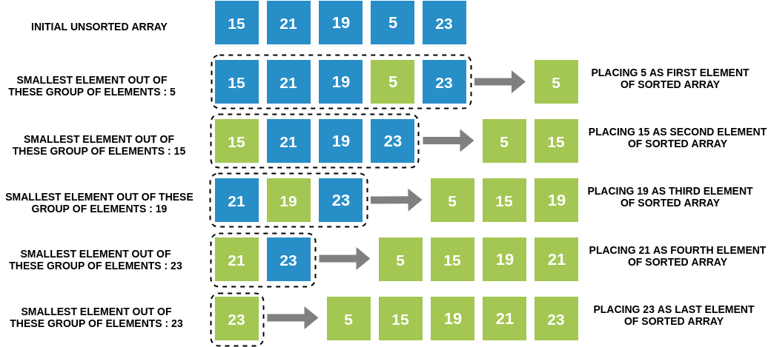

Selection Sort Algorithm
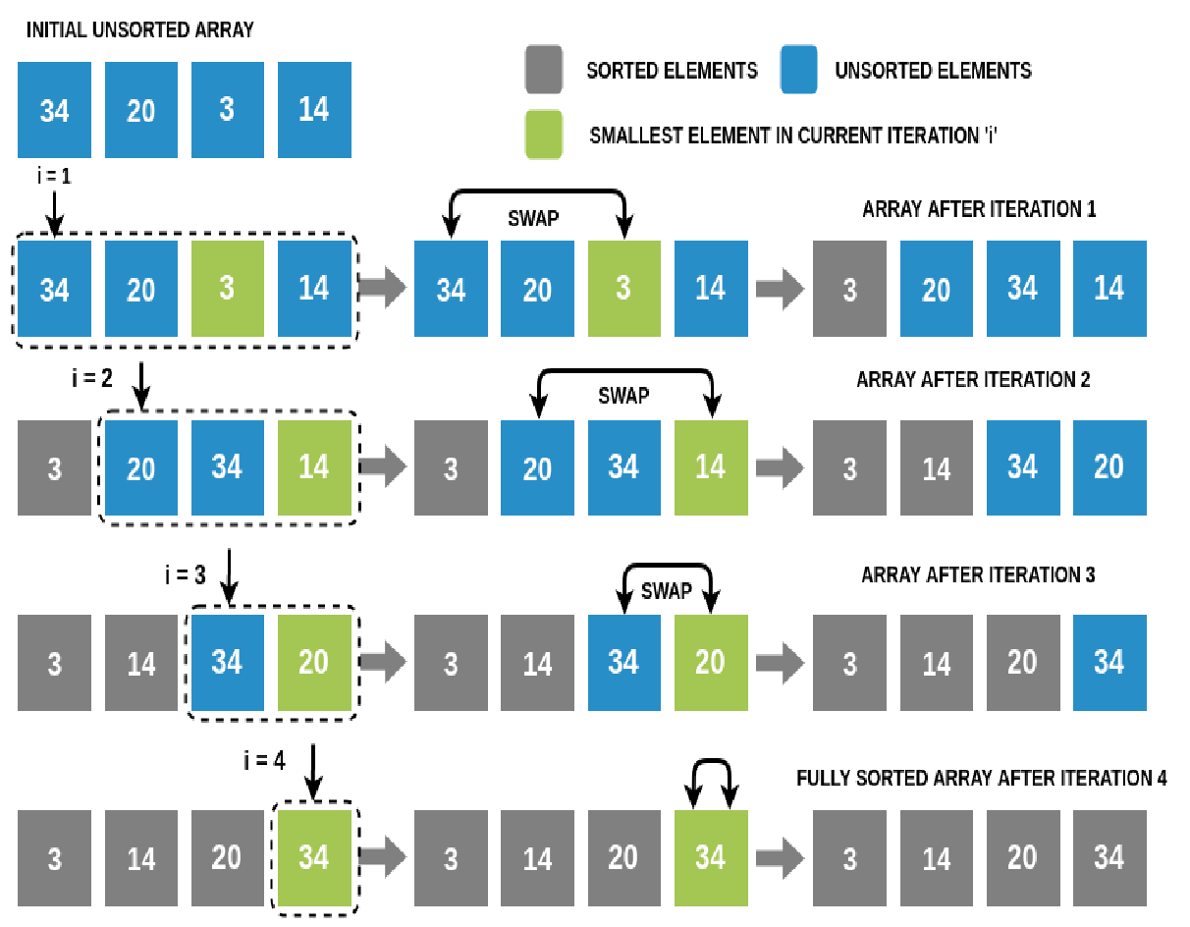

We will perform N-1 iterations on the array (N is the number of elements in the array). In iteration i (1≤i≤N-1):
  - We will traverse the array from the ith index to the end and find the smallest number among these elements. Note that if there are two smallest elements of the same value, we choose the one with the lower index.
  - We will swap this smallest element with the ith element.
  - Hence at the end of the ith iteration, we have found the ith smallest number, and placed it at the ith position in the array.
In the (N-1)th iteration, we will place the (N-1)th smallest element, which is the 2nd largest
element in the array, at the second last position. This will leave us with one element which would already be at its correct place.This completes our sorting! Selection Sort Algorithm.

Running Time of Selection Sort
Let's assume that we are sorting N elements of a given array using Selection Sort.
  - To complete one iteration, we traverse a part of the array (from index i to the end) exactly once (while keeping track of the smallest element encountered so far). Since the longest length we ever traverse in any given iteration is N (in the first iteration when i=1 -> from first to last element), time complexity of completing one iteration is O(N).

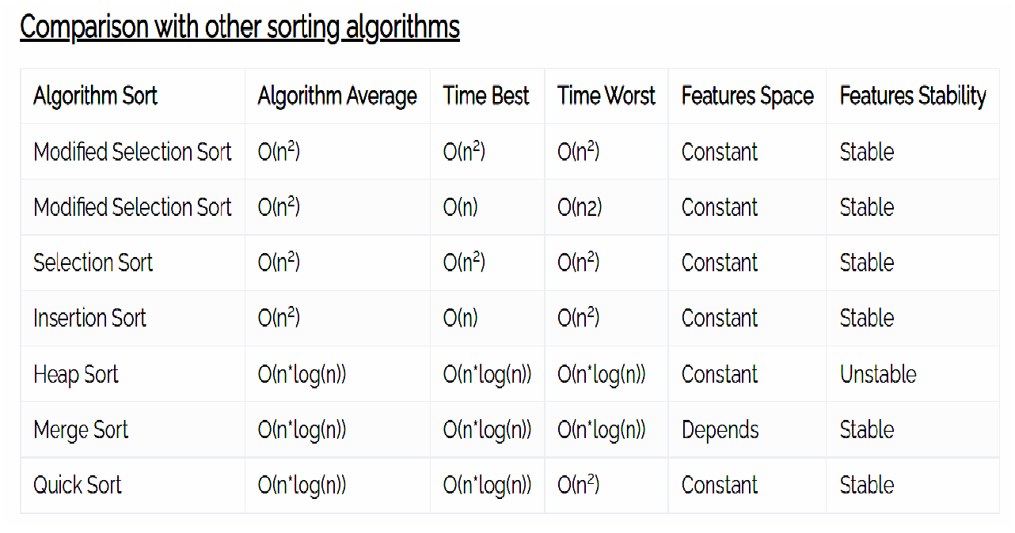
  - In Selection Sort, we run N iterations, each of which takes O(N) time. Hence overall time complexity becomes O(N*N).
- Note that even if the array is fully sorted initially, Selection Sort will take O(N^2) time to complete, just as it will take for a reverse sorted or randomly sorted array.
Space Complexity of Selection Sort
While swapping two elements, we need some extra space to store temporary values. Other than that, the sorting can be done in-place. Hence space complexity is O(1) or constant space.

What is a Stable Sort Algorithm?
A sorting algorithm is said to be stable if two objects with equal keys appear in the same order in sorted output as they appear in the input unsorted array.

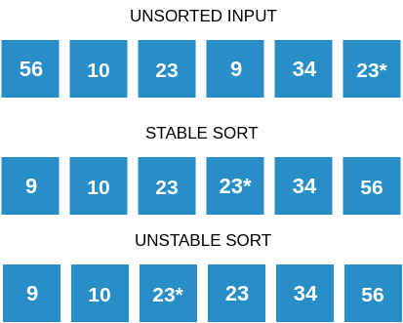

Is Selection Sort Stable?
Yes, Selection Sort is a stable sorting algorithm. When looking for the smallest element, we choose the element with lower index in case there are two or more equal elements that are the smallest elements in the array. This makes sure that we preserve the relative ordering between equal elements.

Questions:
Q 1: What is the time and space complexity of selection sort?
Q 2: If an array is [6,1,9,10] , sort the list by selection sort, step wise.
Q 3: What is the maximum number of comparisons in one iteration for an array of size N?
Q 4: Draw Comparison chart with other sorting techniques with respect to time and space complexity.
Q 5: What is a Stable Sort Algorithm? whether selection sort is a stable algorithm?

Conclusion:
In This way we have studied how to sort , unsorted list of numbers using selection sort.

